Chapter 6, Solution 72.

The output of the first op amp is

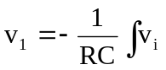dt = 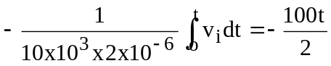

= - 50t

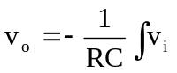dt = 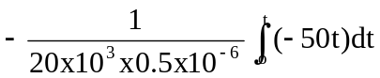

= 2500t²

At t = 1.5ms,
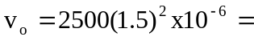 5.625 mV

